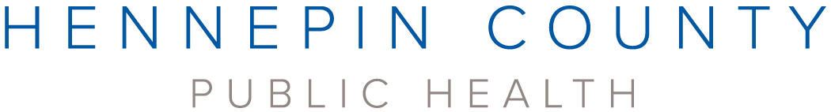

Hennepin County Public Health would like to thank the following organizations for their help informing the 2021-2025 strategic plan. Public Health is grateful for their wisdom and guidance.
2ndChanceProject
African Babies Coalition
Annex Teen Clinic
Archdiocese of Saint Paul and Minneapolis
Between Us, Hennepin Healthcare
Brooklyn Center Community Schools
Community Emergency Assistance Programs (CEAP)
City of Brooklyn Center
City of Brooklyn Park
CommonBond Communities
Community Mediation and Restorative Services
District 287
Headway Emotional Health
Hennepin County Medical Center
Hennepin County's Joint Community Police Partnership
Hopkins On Voice and Schools and Community In Partnership (SCIP)
Hopkins Public Schools
Housing Link
Indian Health Board of Minneapolis
Lao Assistance Center of Minnesota
Mad Dads
Medication and Conflict Resolution at HCMC
Minneapolis American Indian Center
Minnesota Council on Latino Affairs
Minnesota Quality Care
Movefwrd MN
MyHealth Teen Clinic, Hopkins
NorthPoint Health and Wellness Center
NorthPoint Foundation
Northwest Hennepin Family Service Collaborative
Pillsbury United Communities
Potter's House of Jesus Christ
Raíces Sagradas Community Mental Health
Robbinsdale Schools
Shiloh Temple North Minneapolis
Statewide Health Improvement Partnership (SHIP) Hmong Diabetes Prevention Community Leadership Team
Stairstep Foundation
Tasks Unlimited
Twin Cities Recovery Project
Ucare
University of Minnesota, School of Public Health
Way to Grow

